THE TAGISH LAKE METEORITE: NOT YOUR TYPICAL C2 CHONDRITE
M.E. Zolensky¹, K. Nakamura², E. Tonui¹, T. Mikouchi³, M. Gounelle⁴, A Hildebrand⁵, and P. Brown⁶

¹SN2, NASA Johnson Space Center, Houston, Texas 77058, USA. ²Graduate School of Science and Technology, Kobe University, Kobe 657-8510, Japan. ³Dept. Earth and Planetary Science, Graduate School of Science, University of Tokyo, 7-3-1 Hongo, Bunkyo-ku, Tokyo 113-0033, Japan. ⁴ Department of Mineralogy, Natural history Museum, London SW75BD, United Kingdom. ⁵Dept. of Geosciences, University of Calgary, Calgary 2TN 1N4 Canada. ⁶Los Alamos National Laboratory, Los Alamos, NM 87545 USA.

Introduction: Tagish Lake is an intriguing carbonaceous chondrite which bears numerous mineralogical and chemical similarities to CI1 and CM chondrite groups (Brown et al., 2000). However strong differences between Tagish Lake and these two chondrite groups suggest we are dealing with material from a different primitive asteroid. In fact Hiroi et al. (2001) suggest that Tagish Lake may be the first meteorite to originate from a D-class asteroid. Our measured density of Tagish Lake, 1.67+/1 0.05 g/cc., is by far the lowest of any meteorite, and is consistent with the suggestion that this is indeed unique meteoritic material. Here we present our further results on the mineralogy of Tagish Lake at the Scanning Electron Microscope and Electron Microprobe scale.

Results: We have studied 32 thin and thick sections of Tagish Lake, from 10 different individual stones, and identified three lithologies as being present: (1) a dominant carbonate-poor lithology which grades into (2) an-abundant carbonate-rich lithology, and (3) a less abundant, completely aqueously altered, carbonate-poor, sulfide-rich lithology.
Carbonate-poor lithology: This dominant lithology is a phyllosilicate-rich matrix-supported assemblage of fine-grained phyllosilicate-rich clasts, sparse chondrules, aggregates, sparse CAIs and a variety of loose grains of olivine, magnetite, Fe-Ni sulfides, Cr-Ni phosphides and Ca-Mg-Fe carbonates (uncommon). The mineralogy of the matrix is described Mikouchi et al. (2001), and consists mainly of saponite, serpentine and Fe-Ni sulfides. Matrix-supported clasts consist of fine-grained phyllosilicates with minor sulfides and/or magnetite. The majority of chondrule-like objects are partly to heavily aqueously-altered to coarse- and/or fine-grained phyllosilicates, but a few unaltered olivine (Fo₉₉) grains remain. Textures suggest that original chondrules were porphyritic and barred olivine chondrules. Magnetite and/or sulfides are common both inside and rimming chondrules. Most chondrules have fine-grained phyllosilicate-rich rims up to 200 μm thick. Aggregates have a mineralogy similar to that of porphyritic chondrules. We examined several altered CAIs (200-300 μm in size) having fine-grained phyllosilicate-rich rims. They consist of carbonates (dolomite and minor calcium carbonate), spinel and phyllosilicates (saponite and serpentine) homogeneous in composition. Rare perovskite grains are enclosed within dolomite. Olivine grains are common within chondrules, aggregates and isolated in the matrix. The composition of the olivine is mainly forsteritic (Fo₉₉) although a few iron-rich olivines (Fo₆₀) have been found in the matrix. Pyroxene is rarer than olivine and is iron- and calcium-poor (En₉₄₋₉₈Wo₁₋₅). Phyllosilicates are mostly confined to the fine-grained matrix but are also found as coarser grains associated with olivine, magnetite or carbonate. They consist of magnesium-rich serpentine and saponite in agreement with the TEM observations (Mikouchi et al., 2001). Magnetite is very abundant in the matrix but also in clasts, together with olivine, carbonates or phyllosilicates. Framboids are the most common morphologies. Most sulfides are pyrrhotite; pentlandite is much less common. Sulfides are typically fine-grained and display a wide variety of morphologies including rounded, elongated, irregular, and acicular. This latter morphology is otherwise only known from a Kaidun CM1 clast (Zolensky et al., 1996). Cr-Ni phosphide has been found as submicrometer plates within a coarse-grained phyllosilicate; an occurrence known otherwise only from another Kaidun clast (Ivanov et al., 2000). Calcium carbonate is by far the most abundant carbonate, occurring sparsely as very fine polycrystalline grains (<5 μm) scattered throughout the matrix, and forming associations with phyllosilicates and magnetite. It contains no detectable magnesium or manganese, though the iron content can be as high as 1.74 wt % FeO. Dolomite is the second most important carbonate. It is slightly coarser-grained (<10 μm) and usually embayed with phyllosilicates. It can contain up to 7.79 wt% FeO and up to 5.27 wt% MnO. Breunnerite is present only in one iron-rich aggregate. The CaO content is up to 3.46 wt% and the MnO content can reach 0.60 wt%. Other minerals include iron oxides, metal (in olivines), and schreibersite.
Carbonate-rich lithology: This lithology is similar to the previous one except that (1) fine-grained clasts and CAIs are almost absent (2) phyllosilicates are almost entirely saponite, and almost universally fine-grained, (3) andradite is present in association with phyllosilicates and magnetite, (4) magnetite is rare, and (5) Fe-Mg-Ca-Mn carbonates are very abundant, often rimming phyllosilicates. Calcium carbonate is rare. The MnO content of breunnerite can reach 2.91 wt% whereas the CaO content can reach 4.46 wt%. Calcium carbonate contains no detectable MgO or MnO. The iron content of calcium carbonate is below 0.34 wt% FeO. In general, this lithology is notably finer-grained than any other common lithology in carbonaceous chondrites, excepting the finest-grained CV3 dark inclusions (Krot et al., 1995).
Completely aqueously-altered, carbonate-poor, sulfide-rich lithology: This uncommon lithology (appearing in only two thin sections) appears as a rimmed clast. There are abundant completely-altered chondrules, sometimes crosscut by pyrrhotite or pentlandite veins. In fact, sulfides are very common in marked contrast to the bulk Tagish Lake. Magnetite is abundant. Olivine, pyroxene and carbonates are not present. The clast is rimmed by fine-grained, pyrrhotite-rich material. This clast appears identical to material in the Kaidun brecciated chondrite.

Discussion: Tagish Lake is undoubtedly a type 2 carbonaceous chondrite. Abundant phyllosilicates as well as chondrules (however sparse) and common olivine grains in the matrix preclude any other classification. The rarity of glass and chondrules, and the small size of the latter, distinguish it from CR2 chondrites (Weisberg et al., 1993), which actually have a similar matrix mineralogy. Altered chondrules and CAIs, olivine and spinel compositions, and the relative abundance of sulfides are reminiscent of CM2 carbonaceous chondrites. However, the relative abundance and extreme compositional range of carbonates (see Fig. 1), the composition of phyllosilicates, the presence of andradite and the absence of tochilinite are strong differences with the well known CM2 carbonaceous chondrites (Zolensky et al., 1993). Because anhydrous phyllosilicates are common in Tagish Lake and the oxygen isotopes are different from both CI1s and CMs (Brown et al., 2000) we propose that Tagish Lake represents a new kind of type 2 carbonaceous chondrite. This is supported by the bulk density of Tagish Lake (1.67 g/cc), which is far lower than CI or CM chondrites (2.2-2.3 and 2.6-2.9 g/cc, respectively), or any other meteorite for that matter (Wasson, 1974). We have noted similarities between Tagish Lake and some clasts within the enigmatic meteorite Kaidun; possibly there are genetic relationships here worth exploring. In fact the oxygen isotopic composition of the bulk Tagish Lake meteorite is identical to a previously-analyzed C1 clast in Kaidun (Robert Clayton, personal communication 2001). We are currently reassessing the nature of this Kaidun material. Hiroi et al. (2001) suggest that Tagish Lake may be the first meteorite to originate from a D-class asteroid. Perhaps Kaidun has already provided to us samples of this and other new asteroid classes.

References:
Brown P.G. et al. (2000) Science 290, 320-325.
Engrand C. et al. al (2001) LPSC XXXII.
Ivanov A.V. et al (2000) American Mineralogist 85, 1082-1086.
Krot A.N. et al. (1995) Meteoritics 30, 748-775.
Mikouchi T. et al (2001) LPSC XXXII.
Wasson J.T. (1974) Meteorites, p. 175.
Weisberg M.K. et al (1993) GCA 57, 1567-1586.
Zolensky M.E. et al. (1993) GCA 57, 3123-3148.
Zolensky M.E. et al. (1996) Meteoritics & Planet. Sci. 31, 484-493.
Zolensky M.E. et al. (1997) GCA 61, 5099-5115.
Figure 1. Backscattered Electron (BSE) and five element maps of a carbonate aggregate grain from the carbonate-rich lothology. Mn-Fe-Mg rich carbonates have overgrown previous Ca-rich carbonates. Scale bar measures 5 microns.

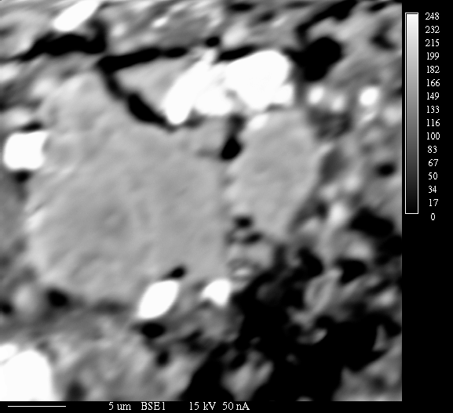
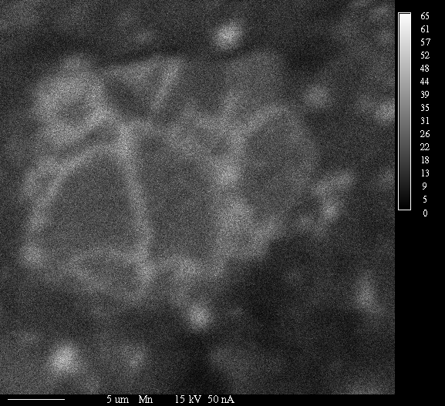
Mn

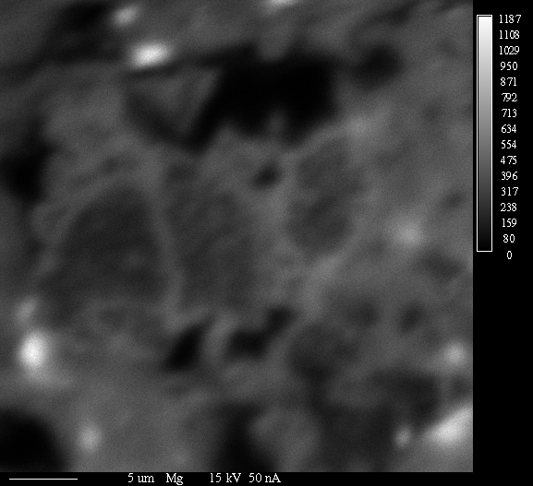
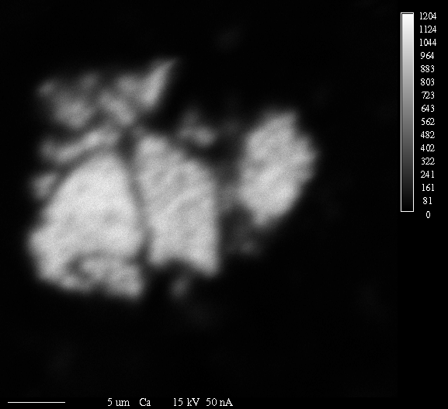
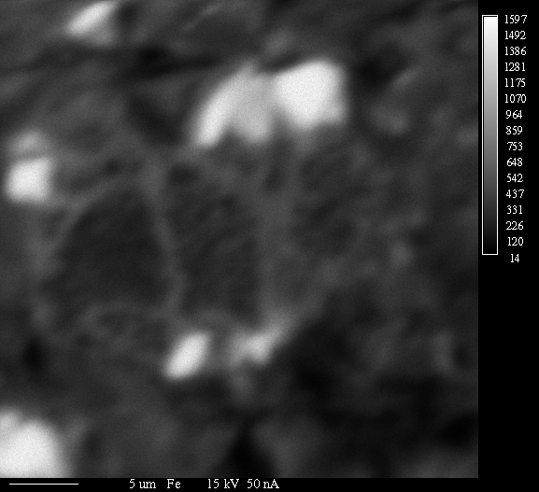
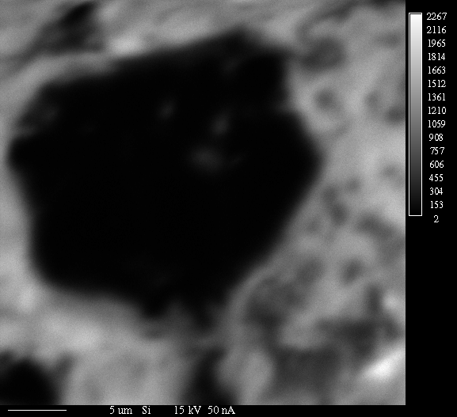
e
Mg
Fe
Si
Ca
BSE

